1-800-817-1204

STAGE CURTAIN LAYOUTS, IT IS ALL ABOUT THE WORKING SPACE

It’s always surprising, and frustrating, how so many stages can be designed without adequate working room for stage presentations, without planning for good sight lines for the audience and without even considering what happens on the stage. It’s not unusual to see a stage layout like Plan A on an architectural drawing. This stage is designed like a “hole in the wall”, with no working space, no way to cross from one side of the stage to another and with the side and rear curtains hanging directly in front of the walls of the stage.
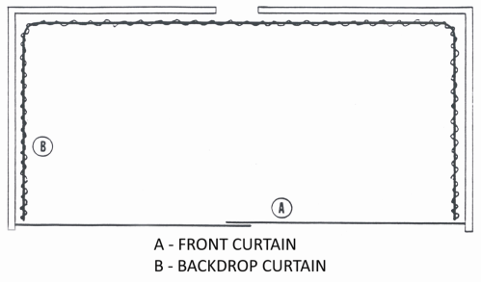
Unfortunately, all too many stages have to contend with this kind of stage planning and this kind of work space, so they may come to you with hope that you can do something for them - and you can.

To understand what can be done for a school stage with inadequate working space, you first need to understand what adequate working space is. There are some “rules of thumb” sizing guidelines that can let us quickly lay out a usable stage:

1. The proscenium arch is the frame through which the audience observes the action on stage. This opening will normally be supplied with a front curtain that opens in the middle and pulls back to both sides of the stage. It will also usually have a valance matching the front curtain, usually dead hung (meaning it doesn’t move) by being tied to a pipe or stapled or tacked to the rear of the proscenium wall. An attractive size for the proscenium opening is to be 50% as high as it is wide. For example, a 30’ wide opening should be 15’ high. Of this 15’ height, the valance should fill 1/4th to 1/3rd of the space. This varies according to no specific rule, but according to what will look best in that specific location. The 15’ opening of our stage then, would have a valance 3’6” high of which 3’3” will be visible below the arch, leaving an opening for audience viewing of ll’9” from stage floor to bottom of valance. It’s not necessary for the front curtain to be more than 18” above the bottom of the valance, so our front curtain is going to be (ll’9” + 1’6” =) 13’3” high. The width should be one half of the opening of 30’ is 15’0”, plus a center overlap of l’0”, or 16’. Most stages have a stacking space on each side of the opening and most curtain tracks will stack to 2” to 3” of stack per foot of track, so our track of 16’ will need 32” to 48” of stack, depending on the track size. Most tracks for a 30’ opening are the medium size track. We’ll figure 32” of stacking is needed, so each half of the track will be 15’0” + 1’0” + 2’8” = 19’0” (rounded off to even feet, since you pay for even feet when buying track). Now we know that each half of the front curtain is 19’0” wide by 13’3” high, and the valance is 31’0” wide (30’ + 6” overlap on each side) by 3’6” high.

2. Since we’re working on a new stage, we need to plan for the cyclorama curtains. “Cyclorama” has come to have the general meaning of “all curtains behind the front curtain” and that’s how we will be using the term. A true cyclorama is a curved construction or curtain, beginning behind the front wall of the stage on one side, curving toward the back wall, running parallel to the back wall, and then curving back to the front wall. This cyclorama can be a carpenter built painted wall (rare) or a seamless curtain tied to a curved pipe suspended from the ceiling. True cycloramas are seldom used on a primary or secondary school stage. Our cyclorama curtains are curtains hung from tracks or pipes in various arrangements. A good rule of thumb for our cyclorama setting is that the stage should be half as deep as the opening is wide. For the 30’ opening we have, the stage setting should be 15’0” deep, which means the rear curtains should be 15’ from the front wall. We need to check the actual stage depth from front wall to back wall, and be sure that we leave at least 3’0” between the back wall and the back curtain, to allow for crossing from one side of the stage to the other side behind the curtain out of sight.

3. It would be best if you do the rest of the layout on graph paper, so that you can scale the side curtains and the borders. A scale of 1/6” to 1’ is easy to work with. Draw the general outline of the stage, and then put in the back curtain we have just sized. Find the center line of the stage and put the center of the back curtain on the stage center line. It’s a good idea to put a center overlap in the back track, so you don’t have a gap where the two halves of the curtain meet. The front opening is 30’, and the rear track should be narrower since the stage setting area should be narrower in the back than the front opening. The sight lines you are going to draw as described in Working Space 2 will determine the width of the rear curtain track. Let’s say for now that you determine that the stage should be 25’0” wide at the back. Half of 25’ is 12’6”, plus a 1’ center overlap, so each half of the track will be 13’6, and the track will be 25’ from one end to the other. Draw the 25’ track on your scaled layout.
4. The typical school, church or small performing arts stage has two sets of side curtains. Locate a point 1’ behind the front curtain and 1’ off - stage from the proscenium opening, and draw a line from that point to the end of the rear curtain track on the same side of the stage. This represents the side curtain track. You obtain the length of the track by measuring the length of the line. The height of the rear curtains and the side curtains can be estimated as the same height as the front curtain. You should check to be sure what this height is by drawing a vertical sight line, described in Working Space 2.
5. The typical stage setting has two or more borders, short curtains running from one side curtain to the other side curtain. Borders have two purposes: (1) to hide the border lights on the stage; (2) to prevent the audience from seeing the ceiling of the stage. Until we draw the vertical sight lines, estimate two borders, divide the stage into thirds, and draw one border in 5’0” behind the front wall (our stage setting is 15’0” deep divided by 3 = 5’.) The second border will be 10’ behind the front wall. Measuring each line on the scaled drawing will tell us how wide each border is. We will estimate the height of the borders as being the same height as the valance until we can check it by sight lines.
Some things to watch out for when planning borders:
(A) If there are border lights present on the stage, you need to plan a border for the audience side of each run of border lights.
(B) All borders should be the same height from the floor. It is not current procedure to try to establish perspective by making each border progressively lower than the one in front of it. Borders may have to be different heights because of some masking problem, but the bottom of all borders should be the same distance from the floor.
Now you have a “typical” stage planned. You may need to modify it after you check working space requirements. The absolute minimum space between curtains and walls for the back curtain and the side curtain is 3’O”. More is desirable, but sometimes hard to obtain. “As a minimum, it is generally considered that the clear, unobstructed width of a stage should be twice the width of the proscenium arch, divided equally to each side. The stage depth should equal roughly one and one - half the width of the arch...A proscenium width of 30’ to 40’ is standard for most dramatic productions. Musicals can afford slightly larger openings, and opera prosceniums may extend to 75’ in width.” This kind of work space is difficult to obtain on the normal school stage, but you will often find proscenium openings much larger than the 30’ or 60’ suggested. The “let’s have enough room to get the whole band on the stage if we need to” syndrome is much in evidence in secondary schools or large houses of worship.
When describing your plan for the stage to your customer, you will find yourself needing to give locating directions, and you will want to be professional in your wording. There is a standard way to describe location on a stage which you should use. All stage directions are given from the actor’s viewpoint when he/she is looking at the audience. Picture yourself standing in the center of the stage looking at the audience. Whatever is to your right is STAGE RIGHT. Whatever is to your left is STAGE LEFT. Whatever is toward the audience (in front of you) is D0WNSTAGE. Whatever is behind you, towards the rear wall, is UPSTAGE. Whatever is behind the curtains or scenery surrounding you, that the audience cannot see, is OFFSTAGE. OFFSTAGE RIGHT means that something is behind the curtains on your right. If you become accustomed to using these terms, your meaning will always be clear to your customer, to us, and to all other stage professionals.
“Upstage” and “downstage” probably came into usage because of the early stage habit of producing “forced perspective” by slanting the stage floor uphill from the audience, to produce the effect of seeing into the distance, of making the stage look deeper. Perspective scenery for the sides and the border curtains all directed the eye towards a vanishing point in the center of the back wall of the stage setting. Since the sides slanted toward that vanishing point, and the overhead border curtains got progressively lower towards the rear, the floor of the stage was also slanted uphill so all four lines guided the eye to the center rear. Even though general forced perspective is no longer used except for elements of scenery, the sides of the stage performance area still slant towards the back to provide perspective adjustment, an adjustment of a stage set to produce for a member of the audience the same visual pattern as would be produced if he were present in the actual area. A more complete description of perspective adjustments is given in Welker, page 133 (see bibliography).
Another reason for the slanted sides of the performance area is consideration of what the audience can see. The further away from the center of the stage a member of the audience sits, the less of the back part of the stage he/she can see. Making the back of the stage area less in width than the front part is an attempt to keep the back part more in keeping with what a good part of the audience can actually see.
The position of power on the stage is downstage, closer to the audience, and facing the audience. When one is “upstaged”, one has another actor moving between the actor and the rear wall, making the front actor turn toward the upstage actor, and thus turning away from the audience and losing the power position. Or, if the upstaged actor doesn’t turn toward the upstager, the motion of the upstager draws audience attention away from the upstaged actor. Either way, actors don’t like to be upstaged and lose the power position, and that’s probably how “upstaging” came to have the connotation it has in general conversation. This, of course, has nothing to do with curtain sizing, but it’s one of the little bits of stage lore it’s helpful to know about, because it can help establish your credentials as a knowledgeable stage curtain supplier. (Factors affecting the audience’s power of attention are discussed at greater length in Welker, page 196.)
The stage shown previously in Plan A, while sadly typical of many stages, is also a stage that provides none of the working space a stage needs. Think for a moment of all that goes on behind the scene in any stage presentation - even the first grade song group.
Somewhere behind the curtains at least one teacher is standing in as stage manager. Also there is at least one student who is working lights, and another student who is working the curtain, and another student who is working sound. There’s quite likely two, three or four students who are in charge of getting props and scenery on and off, and several others standing by waiting for their time to appear, and probably several other miscellaneous bystanders who are just observing.
These people all have to stand somewhere out of sight, and somewhere handy to the performing area there has to be an area in which small props and small flats or scenery elements can be stored for quick use. Maybe the piano is also back there, and some extra lighting equipment, and a microphone stand or two. And quite likely there’s storage of tumbling or wrestling mats or other physical education equipment waiting for the stage to be vacant to double as a small gym.
Then consider what the actors or performers are going to do. Maybe in a little skit, one actor exits the stage on stage left, but for some reason needs to come back on stage from stage right. How does he get across the stage without being seen? If three actors have to come onto the stage from stage left, how do they get over there? Exits, entrances, and crosses are all done behind the scenery or behind the curtains, so there has to be space between the curtains and the surrounding hard walls for people to walk, people to stand, and people to store things.
This space is the “working space” that every stage needs and suffers greatly from if it isn’t provided. So if it isn’t there, it may someday be up to you to suggest how to make it appear.
And even on the worst kind of stage, Plan A, you can make space appear by arranging the curtain layout. The easiest way to do this is to just not pull the front curtain all the way to the ends of the track. Please read about back pack guides on page. Allow at least 3’ on each side of curtain extension, which will look normal and attractive because the back pack guides have made the curtain stack at the on - stage ends of the track, leaving the pleats in position in that unstacked 3’ part. This gives you 3’ of off - stage working space on each side, because you will then plan to start the down - stage (toward the audience) part of the side track 3’ from the wall and about 1’ behind the front curtain track. This side curtain will then slant back toward the rear wall and stop at least 3’ from the back wall - and there’s your working space.

SUGGESTED CYCLORAMA LAYOUTS

The following layouts are not to scale, and are shown as basic suggestions only; they can be modified and changed endlessly to meet specific local conditions and requirements.

LAYOUT # 1
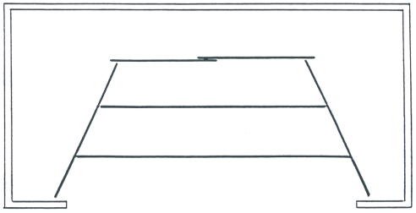
This is probably the basic elementary school arrangement. Each side track has two curtains, and each section of rear track has one curtain, providing seven entrance/exit points.

LAYOUT # 2
Another basic layout, with the added advantage that all the curtains on each curved track can be pulled around to the front of the stage for stacking, to open the stage for activities. Another length of curved track could be added as shown by the dotted lines, to allow the curtains to be pulled along the wall for out-of-the-way storage. There should be two sections of side curtain and one section of rear on each side.

SUGGESTED CYCLORAMA LAYOUTS

The following layouts are not to scale, and are shown as basic suggestions only; they can be modified and changed endlessly to meet specific local conditions and requirements.

LAYOUT # 3
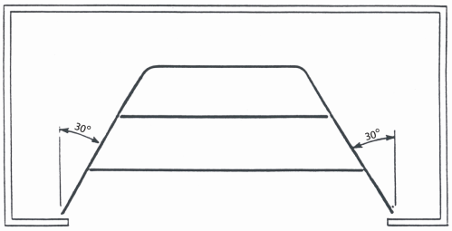
Much the same as layout #2, except that the curves are less than 90 degrees, so the sides of the stage slant toward the back of the stage.

LAYOUT # 4
The four side curtains could be dead hung on pipe battens, or could be on walk draw tracks, allowing them to be gathered for storage at the off stage track end, thus opening the stage up for scenery placement. These side curtain tracks could be extended to the stage side wall to get the curtains completely off the stage, as could the tracks for the two sections of rear curtain.

SUGGESTED CYCLORAMA LAYOUTS

The following layouts are not to scale, and are shown as basic suggestions only; they can be modified and changed endlessly to meet specific local conditions and requirements.

LAYOUT # 5
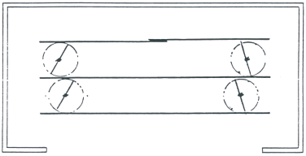
This is an adaptation of #4, and represents a more versatile stage. The four side leg curtains are attached to pivot fixtures, allowing them to be rotated 360 degrees, so they can be set at any angle from parallel to the front curtain (producing a layout like #4) to perpendicular to the front curtain, producing a layout like #1. Note that the legs are installed between the borders, allowing the pivot fixture room to turn.

LAYOUT # 6
Here is probably the most versatile layout for an elementary or secondary school stage. The side legs are on a pivot fixture, but the pivot fixture, instead of being immobile, is now installed in a length of track, so it can be moved back and forth, anywhere along the length of track. Now, the side legs can be rotated anywhere from parallel to perpendicular to the front curtain, and moved on stage or off stage, to widen or make narrower the stage. The tracks in which the pivot fixtures run could be make long enough to end at the stage side walls, allowing the leg curtains to be stacked along the side wall, completely off the stage, out of the way. Note that the pivot leg tracks run between the borders, so the pipe on which the curtain is tied has room to rotate between the borders.
SUGGESTED CYCLORAMA LAYOUTS

The following layouts are not to scale, and are shown as basic suggestions only; they can be modified and changed endlessly to meet specific local conditions and requirements.

LAYOUT # 7
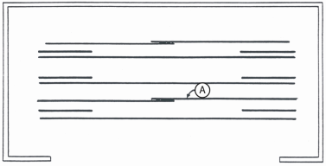
This is a very traditional layout. The side legs are either stationary (tied to a dead hung pipe batten) or on lengths of walk draw track, and are installed closely behind the borders. An intermediate curtain is used, to close off the rear part of the stage. The tracks for the intermediate curtain (A) could be longer than the curtain, so that the stacked curtain is off the stage when it is not in use, OR, if back pack guides are used the ends of the curtains could be left extended on stage, to form another set of leg curtains.

LAYOUT # 8
This is a traditional and very complete high school stage. Two pair of intermediate curtains (CA and CB) is used allowing progressive closing off of the stage. There is a scrim curtain (D) between one third and half way back from the opening, and a sky drop curtain (A) behind the rear curtain (B) Both the sky drop and the scrim is one way roped tracks which extend off stage far enough to allow the curtains to be stacked and wrapped for storage off the stage. The side legs (E) can be either tied to pipes or on walk draw tracks. This layout requires extensive lighting, both to make the scrim work and to light the back parts of the stage. (Borders: F)

SUGGESTED CYCLORAMA LAYOUTS

The following layouts are not to scale, and are shown as basic suggestions only; they can be modified and changed endlessly to meet specific local conditions and requirements.

LAYOUT # 9
Above is another adaptation of layout #8, but with the addition of pivot fixtures in tracks for the side legs, allowing them to be rotated and moved on and off stage. This is a more versatile stage layout than #8 and costs only slightly more.

LAYOUT # 10
One sometimes sees a layout like this that seems to be designed to produce a small or large stage. The section of curtain on the back track can be pulled around to the stack track (A), then the switch (B) changed, and some sections of curtain moved onto the front track, thus reducing the depth of the stage. The switch mechanism is an expensive, difficult-to-install mechanical part, and the same effect could be obtained at almost the same cost, without the requirement for a switch, by putting another track with additional curtains in front of the deep stage track. Storage space for the shallow stage curtains is obtained by extending the end of its track off-stage, beyond the side curtains.

Another adaptation of this two depth layout is sometimes seen, in which the track is a closed oval, with the idea being that the curtains can be put on either the back side of the oval or pulled around to the front side, making the stage deeper or shallower. The problem with this idea is that the audience sees the back side of the curtains on one of the tracks. (If the curtains are put on the back part of the track, facing the audience, then when they’re pulled around to the front part of the track, the back of the curtains faces the audience.) This problem is often realized only after the curtains and track have been installed.
SOME GENERAL INFORMATION TO KEEP IN MIND WHEN TALKING ABOUT STAGE CURTAIN LAYOUTS:
1. Side curtains (legs, wings, teasers) and back curtains are most versatile and usable on walk draw (not roped) tracks. Putting them on a roped track limits the way in which the curtains can be arranged on the track. Roped tracks open in the middle and pull back to both ends (or pull from one end to the other end if a one - way track) and often that arrangement does not fit what a current production requires.
2. The more individual pieces, within reason, that side and back curtains are made in, the more ways they can be arranged on the track, and the more entrance - exit points and scenery location points are available. Side and back curtains should be made in at least two sections per track to allow for an opening in the middle.
3. Sky drops and scrim curtains are best when operated on a roped track, which avoids handling of the curtain. When stacked at the end of the track, they should be protected by a curtain cover. Sky drops and scrims are ideally hung from overhead pipes, but it’s not always possible to fly them, so a track is often used. The weights in the bottom of a sky drop are usually sufficient to taut the curtain, since a sky curtain doesn’t have to be absolutely flat. A scrim curtain needs to be taut and flat to work well. While the weights in the bottom of a scrim help to pull it taut, it can be improved by sewing tielines into the bottom hem, and tying a tauting pipe onto the curtain after it has been extended along the track. While tying a length of pipe onto the extended curtain is difficult because the pipe needs to be in one piece (to avoid creases in the curtain) there is no easier way to provide tautness if the scrim cannot be flown. (The same pipe tauting system can be used for painted backdrops if they cannot be flown.)
4. It’s obvious but sometimes overlooked that side curtains (legs) parallel to the front curtain should not be as high as the border lights, to prevent the curtains from casting shadows behind then.

SUGGESTED CYCLORAMA LAYOUTS
5. Center overlaps on rear curtain tracks are highly recommended so that no gap is visible when the two curtains meet. When there is no center overlap, one often observes the curtains pinned together to eliminate the gap. On side curtains similar to Layout #1 where it isn’t required to stack all the curtains at the end of the track, a center overlap on side curtain tracks would be useful to eliminate the gap which often develops where the curtains butt together.
6. Because curtains have a tendency to retract (to draw in towards the center of the curtain), a curtain made to exactly fit the track will often pull away from the ends of the track. For instance, a 10’ wide curtain on a 10’ wide track may not cover the entire 10’ of track because of this “drawing in” tendency. A good solution is to make the curtain somewhat wider than the track. For example, for a 10’ wide, use an l0’6” or ll’0” curtain. Because good stage curtain fabricating practice uses no less than half widths of material, the extra width of curtain may not cost any more than the narrower curtain. However, the problems with making the curtains a little wider than the track are:
(A) When providing replacement curtains, there may not be enough carriers on the existing track to allow a wider curtain.
(B) When bidding new curtains and track, wider curtains may need more material and more carriers than curtains the size of the track, and if you furnish wider curtains, your price may not compare to competitors furnishing only the minimum requirements.

SIGHT LINES

“Sight lines” refer to what the audience can see of what happens on the stage. A very complete discussion of sight lines is included in Richard Southern’s Proscenium and Sight Lines. A very simplified explanation of sight lines is sufficient for our purposes. There are two different sight lines to consider: horizontal and vertical. Horizontal sight lines determine what the audience can see of the action occurring on the stage proper; that is, how far back on the stage they can see, and how well their sight is blocked from seeing beyond the curtains and scenery to the off stage parts they should not be seeing. The horizontal sight line is drawn by finding the two seats farthest out from the center of the stage: one seat on the right of the auditorium and one seat on the left. When the seats are in a rectangular arrangement, this could be the seat at each end of the front row or the two seats at each end of the back row. If the seating arrangement is on a curve, you need to determine which of the curves has its end seats farther from the stage. Obviously, you will find it easier to use a floor plan for this exercise, but if you don’t have one, you can draw a simplified outline of the stage and the seating arrangement on graph paper.
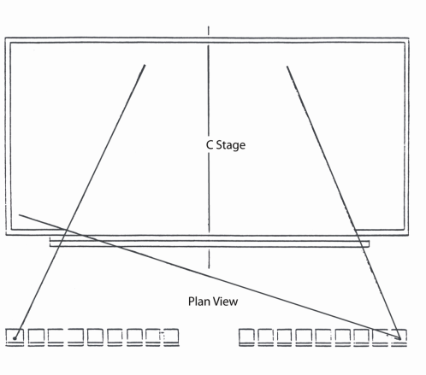
When you have located the seat farthest away from stage center, draw a line from that seat just touching the near edge of the proscenium arch, as shown above. Extend that line past the arch to the back of the stage. Everything on the off stage side of the line is hidden to the person in that seat. Everything on the on stage side of the line can be seen. Now draw the sight line from that same seat but just touching the edge of the proscenium arch on the far side. These two lines show you what the person in that seat will be able to see of what is on the stage. Since those lines represent the poorest view of the stage, at the most extreme angle, the other seats will have a wider view of the stage. You obviously cannot plan the entire stage setting based on what can be seen from these seats, but you need to keep in mind when sizing the performance area these horizontal sight lines are.

Another use for the horizontal sight lines is to be sure that the occupants of these seats cannot see past the side curtains into the offstage area. By drawing lines from the seats at various angles along the side of the stage, you can see if the curtains you have planned block the sight line (as they should) or if the occupants can see past the end of a curtain to off stage. If they can see past the curtain, then the width of the curtain or the angle of the curtain needs to be adjusted so the sight line is blocked.

The vertical sight line is somewhat more complicated. To establish this line, you find the seat closest to the stage. Usually this will be the center seat in the first row of seating, if the rows are straight. If the rows are curved, then you find the “virtual center” seat by drawing a line from one end seat to the other end seat, and finding the center of this line, which is the virtual center of the auditorium. If you can properly block sight lines for this center seat, then the other seats will also be blocked. Assume that the average occupant’s eye is 3’6” from the floor. If the seating is not fixed, but folding chairs are to be used, then, unless you know for sure where the first row of folding chairs will be placed, assume that the closest seat will be 10’ from the edge of the stage. Your sight line starting point will then be 10’ out and 3’0” up where the occupant’s eye will be assumed to be.
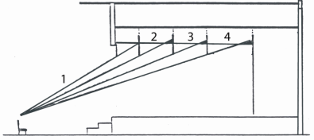
The first sight line to draw is that which passes immediately under the valance (#1). Draw a line from the “eye point” under the valance and continue it up to the ceiling of the stage. This is what the audience will see unless you block it with a border. You know where the bottom of the border should be: at the same height from the floor as the bottom of the valance. Draw the first border at a location that will stop the sight line from seeing the ceiling of the stage. I find it helpful to draw a construction line parallel to the stage floor at the level of the valance bottom and another at the top of the valance. Wherever the sight line cuts that top line is where the first border should be located, about 5” in front of the intersection.

Draw the first border in, and then draw sight line 2 under the border from the eye point in the audience. Where this #2 line cuts the top of your parallel construction lines is where the next border should go, about 6“in front. Then, draw line #3 under this border, to establish the location of the third border. Sight line #4 will then establish the location of the rear curtain.

You will immediately see that there are a lot of variables to work with. If you make the valance just a little longer, then the first sightline moves back on the stage, and the second then moves a little farther back. You can make the borders higher than the valance, and change the sight lines. If border lights are already installed, then you have to experiment with heights of valances and borders in order to provide adequate masking with fixed locations of borders. Sometimes you may find it necessary to put more borders on the stage than you think appropriate, due to bad sight lines.

It’s also necessary to consider the height of the side curtains when drawing these sight lines. Beware of the “unmasked triangle” on side curtains: when the audience is looking at the borders, and you have adequately stopped their sight line from the ceiling, be sure that they cannot look over the tops of the side curtains. If the sight line drawn under the border forms a triangle with the side curtain, the audience will see through this triangle. The shaded triangle in the illustration above represents an “unmasked triangle” and the audience can see over the top of the side curtain into offstage.

Arnold, Richard L., Scene Technology (Englewood Cliffs, NJ: Prentice Hall, 1990) p. 196

